Software Quality Engineering

Open Ended Questions

1. *SQA (Expanded Definition):* A systematic, planned set of actions necessary to provide adequate confidence that the software development process or the maintenance process of a software system product conforms to established functional technical requirements as well as with the managerial requirements of keeping the schedule and operating within the budgetary confines.

It is claimed that the expanded definition of SQA corresponds with client satisfaction.

* + Do you Agree?
  + Yes/No; provide arguments.

1. George is an exceptional programmer. Testing his software modules reveals very few errors, far fewer than the team’s average. He keeps his schedule promptly, and only rarely is he late in completing his task. He always finds original ways to solve programming difficulties, and uses an original, individual version of the coding style. He dislikes preparing the required documentation, and rarely does it according to the team’s templates.He was called to the chief’s office and warned by the company’s chief that he would be fired unless he began to fully comply with team’s coding and documentation instructions.
   * Do you agree with the chief?
   * Yes/No. Justify your opinion.
2. When or at what defect level do we need to Stop Testing?
3. Does a project of only 40 working days duration, to be developed by one professional entity, justify the investment of a man-day in order to prepare a full scale quality and development plan?
4. Is it necessary to prepare a quality plan document for internal projects? Yes/no. Justify.
5. Why do we need quality models when we have various software process models? What is the significance of Software Quality Models?
6. When or at what defect level we need to stop testing?(book page 64)
7. Every statement or unit in a component must be covered before integration testing. The coverage criterion ensures that **certain types of faults are detected and removed**, thus **reducing the number of defects** to a lower level,
8. Attribute Tradeoffs:
   * Usability vs Functionality
   * Performance vs Security
   * Usability vs Portability
9. Differentiate between walkthrough and inspection.
10. Walk through is informal, initiated by author, no pre preparation, unplanned, done with people within organization, informal procedures.

Inspection is formal, initiated by team, pre preparation, planned, stakeholders, recorders are involved, formal procedures.

1. When do we prefer walkthrough and when do we prefer inspection to review software products?
2. Walkthrough when low cost, project team not available, want to see software quality in initial stages, low risk project.

Inspection when professionals available, high risk project, high budget available, long schedule so can accomodations time of reviews and inspection

1. Does a project to be implemented by 3 professionals with a total investment of 25 Mondays reqd full scale planning?

* If the project is totally reusable then no planning is required. Only minor changes in schedule and budget will be done.
* If the project is complex then full scale planning is required and if deadline is near so we can prioritize things on which to focus more (decided by team lead). Agile model can be used b/c less documentation.
* If staff is 5 years exp no full scale planning reqd.
* If staff is unexperienced then full scale planning under expert supervision reqd ha.
* If project is outsourced then small scale planning reqd to manage, meet with them and verify that the product is correct or not.

1. Does a project implemented and used by same organization reqd planning?
2. Software developed and used internal requires small scale planning keeping in mind that it should not exceed our budge while deadline may compromise, because it is our software so any defect will not impact our business name in the market. Only task can be divided and assigned to team members so that project is organized.
3. What is the difference between QA and QE activities?
4. QA aims to prevent defect, means it ensures that every thing is going according to SRS and predefined standards or not. It is related to verification.

QE is an engineering framework provided by organization to ensure quality. It has broader scope that how to handle the incoming activities/projects. In QE, we analyze data from one project, do minor changes if needed and apply to similar project in future.

1. In what circumstances we use V-model and in what situations we should avoid V-model? What are the advantages and disadvantages of V model?
2. We use V-model when we have to perform large amount of testing. For doing testing in each and every activity and component of project lifecycle we use V-model. For small projects when requirements are clearly defined, and time is limited.

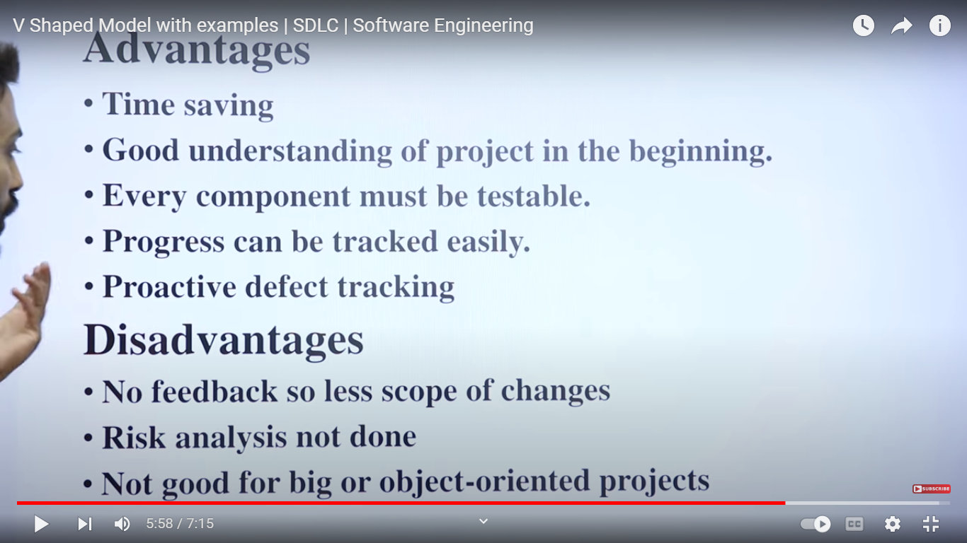

1. Does QA need coding?
2. QA should have a little bit knowledge about coding to know how code is working, it will help him in testing the product (using White Box Testing). It is a plus point for QA but not necessary.
3. What are QA alternatives?
4. Defect prevention, defect detection, defect containment.
5. When to use automation testing and when to use manual testing?
6. We use manual testing when the automation testing is not possible on the functionality or when automation testing gives inaccurate results. Like when we are doing usability testing, then first of all, usability testing tool is not available, because tool cannot tell how the color, format, layout is looking, button design is good or not, is it easy for user or not etc. In this case we perform manual testing.

Similarly, we perform automation testing where manual testing takes lots of time and effort or functionality is complex or we have tool available for testing which gives accurate results. Like when we are doing regression testing, load testing, performance testing etc. In this scenario automation is best because using script it will easily do testing again and again (Regression Testing), adding lot of data on application to do load testing can be easily done via script in automation testing manually it will take lot of time and effort. In this case, we will perform automation testing.

1. Why use SQA models when we have software development process model?
2. We use SQA models to map the requirements to quality factor, to know which quality factor to achieve. We quantify that quality factor to know that how much quality factor to achieve. While software development process model is used to handle overall SDLC process which only tells what requirements to fulfill in requirement phase. It does not tell how to achieve quality that’s why SQA models are used.
3. What is the significance of SQA model?
4. When to perform software testing?
5. We need to perform testing when we need to check the quality of our software product, to find out bugs, errors in our software code, to check the UI of software (black box testing), when we have to perform validation on our software project means to check that the developed software is according to the specifications mentioned in SRS.
6. Do Following Comparisons:
7. Failure Intensity vs failure vs software reliability
8. I/O Devices vs Software Reliability
9. Time and Space Complexity vs Software Reliability
10. All web services are API. Do you agree with this opinion? Justify your opinion with a suitable example.
11. Yes all web services are APIs but not all APIs are web services. Reason is that what ever we see on website or on internet comes from a server. So to access the content from server, we need APIs which goes to server, server authenticates them and perform the service requested by API. E.g I open a website called Facebook, first I type its url then request send to Facebook server via API, server sends the facebook page to user, then for posting, liking, commenting on posts, creating groups and pages, searching etc is done and save in database with the help of APIs. When I perform any of the above action then API is sended to server which stores the updations in database. So everything we get from web is done via API which connects frontend with backend, without server, backend and database web services cannot run. So all the services we get on web is done via API.